Lab 2 Answers

Task 1: If the task has been submitted before calling the shutdown() it will run normally.
The tasks will be rejected if submitted after shutdown() since the Executor no longer accepts new tasks.

Task 2:

a) If we call the get() method from a task that is not done, it will return false.

b) we can interrupt and cancel a task by using the Executor Method boolean cancel(boolean mayInterruptIfRunning);

If the task has finished or been cancelled earlier the method will return false
if the task is waiting, it will be canceled and never begin its execution. So method will return true.
If the task is already running and mayInterruptIfRunning is true it will be canceled.
If it’s already running and value of mayInterruptIfRunning is false, it will not be canceled.

c) Execute(task) will simply start and execute the tasks, but submit will return a future object to manage the tasks which will enable it to cancel the tasks prematurely with the cancel method explained above, and wait for the task to finish with get().

Task 3:

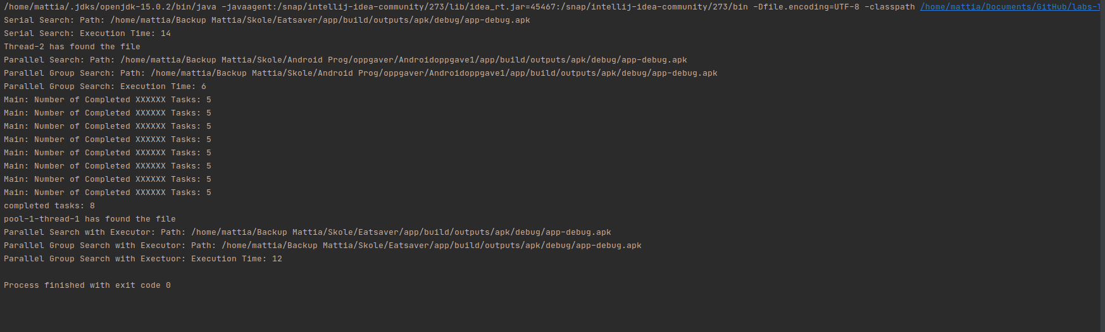
We can clearly see that the execution time is shorter for the last method but not that much.

